**LAB : 1**

**OBJECTIVE :** Basic implementation of conditional, iterative statements in JAVA.

**Requirements :** Computer System, JAVA Development Kit

**Programs :**

1. **Program to find the greater of the two given numbers given as input**

import java.io.*;

class largest{

public static void main(String args[]) throws IOException{

BufferedReader br=new BufferedReader(new InputStreamReader(System.in));

int a,b;

System.out.print("Enter two numbers :");

a=Integer.parseInt(br.readLine());

b=Integer.parseInt(br.readLine());

if(a==b)

System.out.println("\nTwo numbers are equal");

else if(a>b)

System.out.println("\n"+a+" is greater");

else

System.out.println("\n"+b+" is greater");

}

}

**Output :**

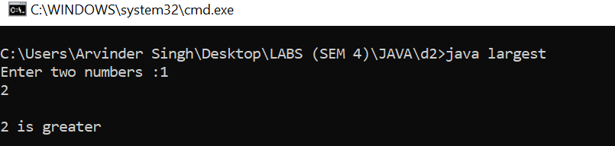

1. **Program to show the count of the number of command line arguments passed by user.**

import java.io.*;

class count{

public static void main(String[] args) //throws IOException

{

System.out.println("No of arguments:"+args.length);

}

}

**Output :**



1. **Program to print the Pascal Triangle**

import java.io.*;

import java.util.*;

class PascalTriangle{

public static void main (String[] args) throws IOException{

Scanner sc = new Scanner(System.in);

System.out.print("Enter the number of row of pascal triangle :");

int n =sc.nextInt();

int []a=new int[n];

a[0]=0;

a[1]=1;

int []b=new int[n];

int [] temp;

for (int i = 0; i < n; i++)

{

for(int k=n-i;k>1;k--)

System.out.print(" ");

// No of terms in row equal to line number

for (int j = 0; j <= i; j++)

{

// First and last

if (i == j || j == 0)

b[j] = 1;

else // Other values

b[j] = a[j-1] + a[j];

System.out.print(b[j]+" ");

}

System.out.println("");

temp=a;

a=b;

b=temp;

}

}

}

**Output :**

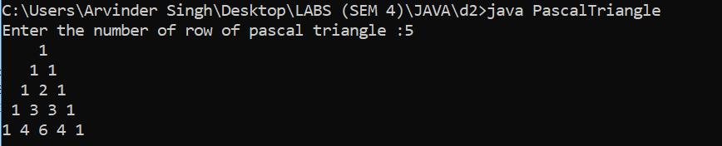

1. Write a menu driven program to print various patterns (box, oval, arrow and diamond):-

**LAB : 2**

**OBJECTIVE :** Implementationof classes and objects in JAVA

**Requirements :** Computer System, JAVA Development Kit

**Programs**

1. Program to find whether the given triplet is Pythagorean or not

import java.util.*;

import java.io.*;

class pythagoras{

public static void main(String[] args) {

System.out.println("Enter the sides of the triangle");

Scanner s1=new Scanner(System.in);

int a=s1.nextInt();

int b=s1.nextInt();

int c=s1.nextInt();

if(a>0&&b>0&&c>0){

if(a*a+b*b==c*c)

System.out.print("\nThis is a pythogorean triplet with hypotenuse- "+c);

else if(a*a+c*c==b*b)

System.out.println("\nThis is a pythogorean triplet with hypotenuse- "+b);

else if(b*b+c*c==a*a)

System.out.println("\nThis is a pythogorean triplet with hypotenuse- "+a);

else System.out.println("This is not a pythagorean triplet");}

else System.out.println("Invalid Entries");

}

}

**Output :**

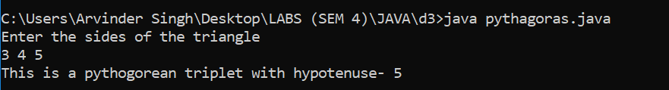

1. Program to calculate area, circumference and diameter of a circle whose radius is given using class.

import java.util.Scanner;

class circle{

private float r,d,c,a;

final float PI=3.14159f;

public void getData(float input){

r=input;

}

public void print(){

d=2*r;

c=2*PI*r;

a=PI*r*r;

System.out.println("\nRadius :"+r);

System.out.println("Diameter :"+d);

System.out.println("Circumference :"+c);

System.out.println("Area :"+a);

}

}

class Prog2{

public static void main(String[] args) {

Scanner sc=new Scanner(System.in);

circle c=new circle();

System.out.print("Enter the radius of circle :");

float input=sc.nextFloat();

c.getData(input);

c.print();

}

}

**Output :**

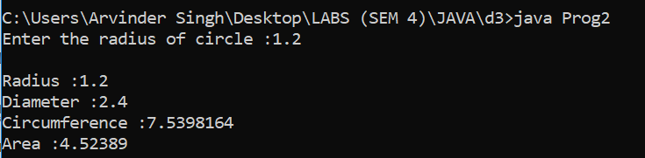

**7.** Program that maintains bank account and impliment debit operation.

import java.util.Scanner;

class account{

private int id;

private float balance;

account(int inId,float inBalance){

id=inId;

balance=inBalance;

}

public void debit(float inWithdraw){

if(inWithdraw>balance)

System.out.println("Insufficient Balance\nYour Balance is Rs."+balance);

else{

balance-=inWithdraw;

System.out.println("Rs."+inWithdraw+ " withdrawn from your account\nNew balance :Rs."+balance);

}

}

}

class Prog3

{

public static void main(String[] args) {

Scanner sc=new Scanner(System.in);

account a[]=new account[5];

for(int i=0;i<5;i++)

{

a[i]=new account(i+1,(100-i)*(i+1));

}

System.out.print("\nEnter your id (1-5) and amount to withdraw :");

int choice=sc.nextInt();

float amt=sc.nextFloat();

a[choice-1].debit(amt);

}

}

**Output :**

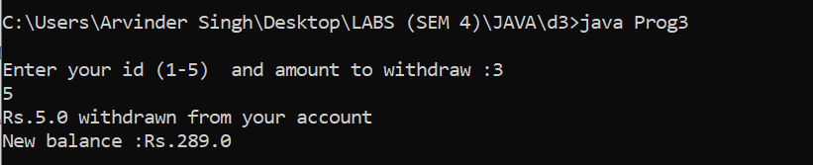

**7.** Program to calculate salary on the basis of number of work hours

import java.util.Scanner;

class salary{

private int id;

private float salary,salaryPerHour,hours;

public void getData(int inId,float inSalaryPerHour, float inHour){

id=inId;

salaryPerHour=inSalaryPerHour;

hours=inHour;

if(hours<=40)

salary=hours*salaryPerHour;

else{

salary=40*salaryPerHour;

salary+=(hours-40)*salaryPerHour/2;

}

}

public float print(){

return salary;

}

}

class Prog4

{

public static void main(String[] args) {

Scanner sc=new Scanner(System.in);

salary s[]=new salary[3];

for(int i=1;i<=3;i++)

{

s[i-1]=new salary();

System.out.println("Enter the Salary/hr (in Rs.) and Total work hours for Worker"+i);

float inSalaryPerHour,inHours;

int inId=1;

inSalaryPerHour=sc.nextFloat();

inHours=sc.nextFloat();

s[i-1].getData(inId,inSalaryPerHour,inHours);

}

for(int i=1;i<=3;i++)

{

float ans=s[i-1].print();

System.out.println("Gross Salary of worker with ID="+i+" is Rs."+ans);

}

}

}

**Output :**

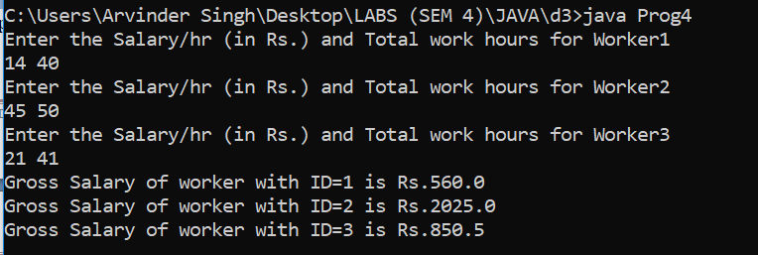

**LAB : 3**

**8.** Program to put even and odd elements of an array n two separate arrays

import java.util.Scanner;

class OddEven{

public static void main(String[] args) {

Scanner sc=new Scanner(System.in);

System.out.print("Enter the number of elements to be inserted in array :");

int n=sc.nextInt();

int []a = new int[n];

System.out.print("\nEnter "+n+" elements :");

for(int i=0;i<n;i++)

a[i]=sc.nextInt();

int []odd=new int [n];

int []even=new int [n];

int o=0,e=0;

for(int i=0;i<n;i++){

if(a[i]%2==1)

odd[o++]=a[i];

else

even[e++]=a[i];

}

System.out.println("\nOdd elements are");

for(int i=0;i<o;i++)

System.out.print(odd[i]+" ");

System.out.println("\nEven elements are");

for(int i=0;i<e;i++)

System.out.print(even[i]+" ");

}

}

**Output :**

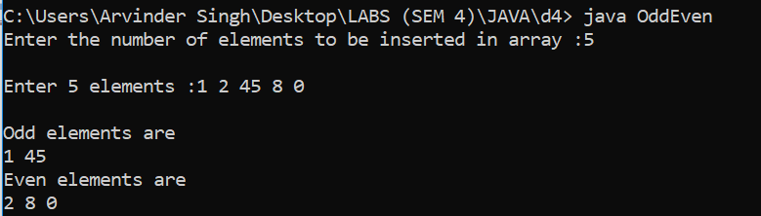

**9.** Program to display upper and lower triangular matrix for a given square matrix.

import java.util.Scanner;

class TriangularMatrix{

public static void main(String[] args) {

Scanner sc=new Scanner(System.in);

System.out.print("Enter the order of (n*n) sqaure matrix :");

int n=sc.nextInt();

int [][]a = new int[n][n];

for(int i=0;i<n;i++)

a[i]=new int[n];

System.out.println("\nEnter the elements of matrix in row-major order :");

for(int i=0;i<n;i++)

for(int j=0;j<n;j++){

a[i][j]=sc.nextInt();

;

}

System.out.println("\nEntered Matrix is :\n");

for(int i=0;i<n;i++){

for(int j=0;j<n;j++){

System.out.print(a[i][j]+" ");

}

System.out.println("");

}

System.out.println("\nChoose one from following :");

System.out.println("1.Display Upper triangular matrix\n2.Display Lower triangular matrix\n3. Exit");

int choice=sc.nextInt();

do{

switch(choice){

case 1:

System.out.println("\nUpper Triangular Matrix is :\n");

for(int i=0;i<n;i++){

for(int j=0;j<n;j++){

if(i>j)

System.out.print("0 ");

else

System.out.print(a[i][j]+" ");

}

System.out.println("");

}

break;

case 2:

System.out.println("\nLower Triangular Matrix is :\n");

for(int i=0;i<n;i++){

for(int j=0;j<n;j++){

if(i<j)

System.out.print("0 ");

else

System.out.print(a[i][j]+" ");

}

System.out.println("");

}

break;

case 3:

break;

default:

System.out.println("Enter a valid option");

}

System.out.println("\nChoose one from following :");

System.out.println("1.Display Upper triangular matrix\n2.Display Lower triangular matrix\n3. Exit");

choice=sc.nextInt();

}while(choice!=3);

}

}

**Output :**

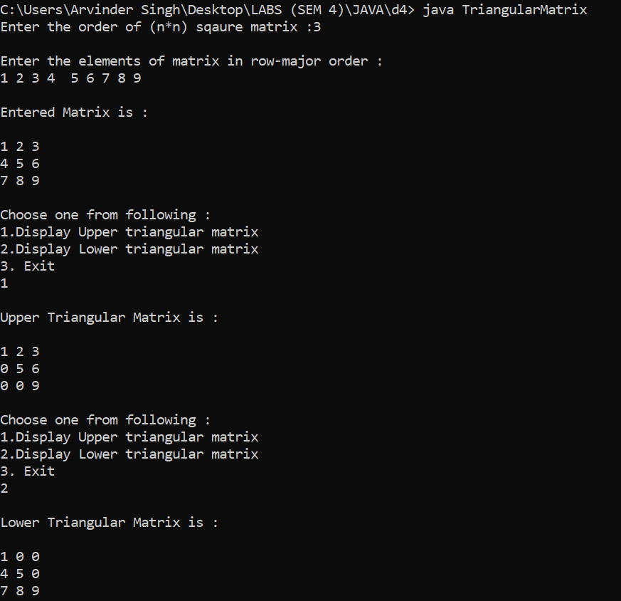

**10.** Program to Multply two matrices (if feasible)

import java.util.Scanner;

class MatrixMultiply{

public static void main(String args[])

{

int m, n, p, q, sum = 0, c, d, k;

Scanner in = new Scanner(System.in);

System.out.println("\nEnter the number of rows and columns of first matrix");

m = in.nextInt();

n = in.nextInt();

int first[][] = new int[m][n];

System.out.println("\nEnter elements of first matrix");

for (c = 0; c < m; c++)

for (d = 0; d < n; d++)

first[c][d] = in.nextInt();

System.out.println("\nEnter the number of rows and columns of second matrix");

p = in.nextInt();

q = in.nextInt();

if (n != p)

System.out.println("\nThe matrices can't be multiplied with each other.");

else

{

int second[][] = new int[p][q];

int multiply[][] = new int[m][q];

System.out.println("\nEnter elements of second matrix");

for (c = 0; c < p; c++)

for (d = 0; d < q; d++)

second[c][d] = in.nextInt();

for (c = 0; c < m; c++) {

for (d = 0; d < q; d++) {

for (k = 0; k < p; k++)

sum = sum + first[c][k]*second[k][d];

multiply[c][d] = sum;

sum = 0;

}

}

System.out.println("\nProduct of the matrices:");

for (c = 0; c < m; c++) {

for (d = 0; d < q; d++)

System.out.print(multiply[c][d]+"\t");

System.out.print("\n");

}

}

}

}

**Output :**

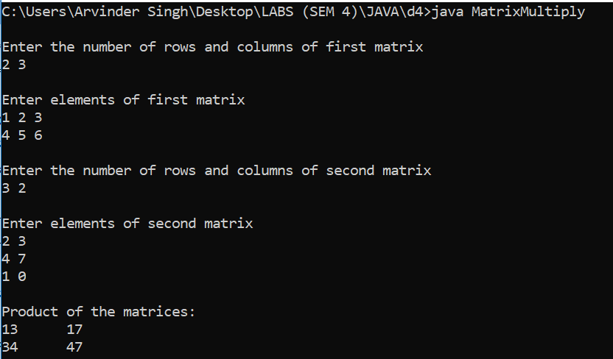

**11.** Program to calculate frequency of digits (0-9) in 1-D array

import java.util.Scanner;

class Frequency{

public static void main(String[] args) {

Scanner sc=new Scanner(System.in);

System.out.print("Enter the number of elements to be inserted in array :");

int n=sc.nextInt();

int []a = new int[n];

int []count=new int[10];

for(int i=0;i<10;i++)

count[i]=0;

System.out.print("\nEnter "+n+" elements (0 to 9) :");

for(int i=0;i<n;i++){

a[i]=sc.nextInt();

count[a[i]]++;

}

System.out.println("\nFrequency of numbers :");

System.out.println("Number Frequency");

for(int i=0;i<10;i++)

if(count[i]!=0) //Number Frequency

System.out.println(i+" : "+count[i]);

}

}

**Output :**

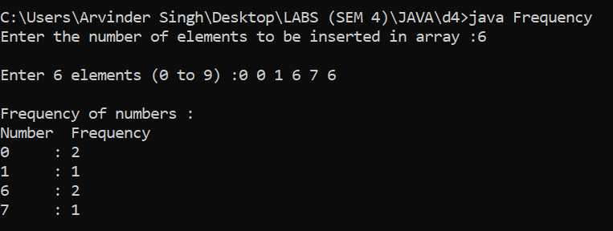

**12.** Program (menu-driven) for insertion , deletion and to display a 1-D array

import java.util.Scanner;

class Array{

public static void main(String[] args) {

Scanner sc=new Scanner(System.in);

System.out.print("Enter the number of elements to be inserted in array :");

int n=sc.nextInt();

int pos=0;

int []a = new int[100];

System.out.print("\nEnter "+n+" elements :");

for(int i=0;i<n;i++)

a[i]=sc.nextInt();

System.out.println("\nChoose one from following :");

System.out.println("1.Display array\n2.Insert an element an element in array\n3.Delete an elemrnt from array\n4.Exit");

int choice=sc.nextInt();

while(choice!=4){

switch(choice){

case 1:

System.out.println("\nArray is :\n");

for(int i=0;i<n;i++)

System.out.print(a[i]+" ");

break;

case 2:

System.out.print("\nEnter the positon where you want insert element :");

pos=sc.nextInt();

pos--;

if(pos>n || pos <0)

System.out.print("\nInvalid position");

else{

System.out.print("\nEnter the element you want to insert :");

int element=sc.nextInt();

n++;

//1 2 3 4 5 *

for(int i=n-2;i>=pos;i--){

a[i+1]=a[i];

}

a[pos]=element;

System.out.println("\nElement inserted");

}

break;

case 3:

System.out.println("\nArray is :\n");

for(int i=0;i<n;i++)

System.out.print(a[i]+" ");

System.out.print("\nEnter the positon from where you want to delete element :");

pos=sc.nextInt();

pos--;

if(pos>n-1 || pos <0)

System.out.print("\nInvalid position");

else{

//1 2 3 4 5 *

for(int i=pos;i<n;i++){

a[i]=a[i+1];

}

n--;

System.out.println("\nElement deleted");

}

break;

case 4:

break;

default:

System.out.println("Enter a valid option");

}

System.out.println("\nChoose one from following :");

System.out.println("1.Display array\n2.Insert an element an element in array\n3.Delete an elemrnt from array\n4.Exit");

choice=sc.nextInt();

}

}

}

**Output :**

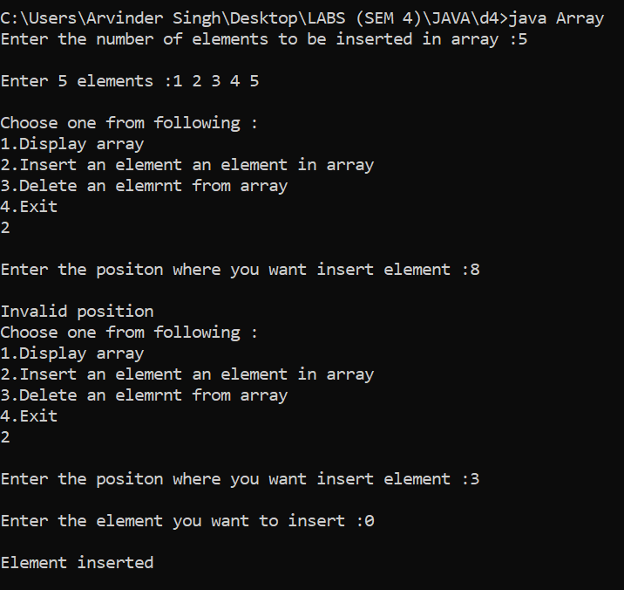

**Contd.**

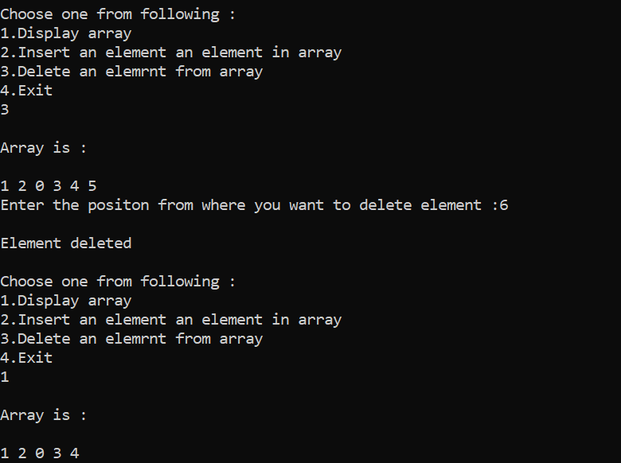

**LAB : 4**

**14.** Program to

class Parent

{

public void showp()

{

System.out.println("this is parent class");

}

}

class Child extends Parent{

public void showc(){

System.out.println("this is child class");

}

}

class Program

{

public static void main(String args[])

{

Parent p=new Parent();

Child c=new Child();

p.showp();

c.showc();

c.showp();

}

}

**Output :**

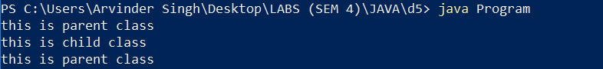

**15.** Program to

class Rectangle

{

double l,b;

public Rectangle(){}

public Rectangle(double len,double bre)

{

l=len;

b=bre;

}

public void perimeter()

{

System.out.println("Perimeter is :"+2*(l+b));

}

public void area()

{

System.out.println("Area is :"+l*b);

}

}

class Square extends Rectangle

{

public Square()

{

l=b=0.0;

}

public Square(double len)

{

super(len,len);

}

}

class Program2

{

public static void main(String args[])

{

Rectangle r=new Rectangle(3.0,4.0);

r.perimeter();

r.area();

Square s=new Square(7.0);

s.perimeter();

s.area();

}

}

**Output :**

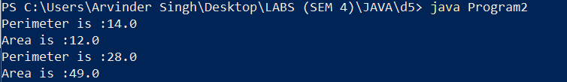

**16.** Program to

import java.util.Scanner;

class Shape{

public void aboutShape(){

System.out.println("This is shape");

}

}

class Circle{

double r;

public Circle(){

r=0;

}

public Circle(double rad){

r=rad;

}

public void about(){

System.out.println("This is circular Shape");

}

}

class Rectangle extends Shape{

double l,b;

public Rectangle(){l=b=0.0;}

public Rectangle(double len,double bre)

{

l=len;

b=bre;

}

public void aboutR(){

System.out.println("This is Rectangular shape");

}

}

class Square extends Rectangle{

public Square(){super();}

public Square(double len)

{

super(len,len);

}

public void aboutS(){

System.out.println("Square is a Rectangle");

}

}

class Program3{

public static void main(String[] args) {

Square s=new Square(3);

s.aboutShape();

s.aboutR();

s.aboutS();

}

}

**Output :**

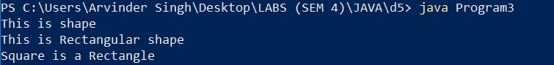

**17.** Program to

class Area{

public void area(double l,double b){

System.out.println("Area of triangle is "+ l*b/2);

}

public void area(double r){

System.out.println("Area of circle is "+ 3.14159*r*r);

}

}

class Program4{

public static void main(String[] args) {

Area a=new Area();

a.area(3,5);

a.area(1.2);

}

}

**Output :**



**LAB : 5**

**18.** Program to

**Output :**